**MEDICAL INVENTORY MANAGEMENT**

**College Name: CHIKKANNA GOVT ARTS COLLEGE**

**College Code: bru06**

**Team ID :** NM2025TMID26176

**Team Size :** 5

**Team Leader :** ROHITH SABARAISHWAR V

**Email :** hiphoprohith1234@gmail.com

**Team member :** RANGANATHAN D

**Email :** ranganathanr838@gmail.com

**Team member :** RAKESH M

**Email :** rakeshmuruganantham@gmail.com

**Team member :** SABARIGURU K

**Email :** sabariguru8079@gmail.com

**Team member :** VIGNESH V

**Email :** vicky.kasr@gmail.com

# 1.INTRODUCTION

The Medical Inventory Management System is a vital solution for healthcare facilities, designed to ensure accurate tracking, efficient restocking, and timely distribution of medical supplies. Built on the Salesforce platform, it helps streamline operations, reduce waste, and maintain critical inventory levels. With its intuitive interface and robust features, this system supports healthcare providers in delivering reliable patient care while optimising resource management.

## Project Overview

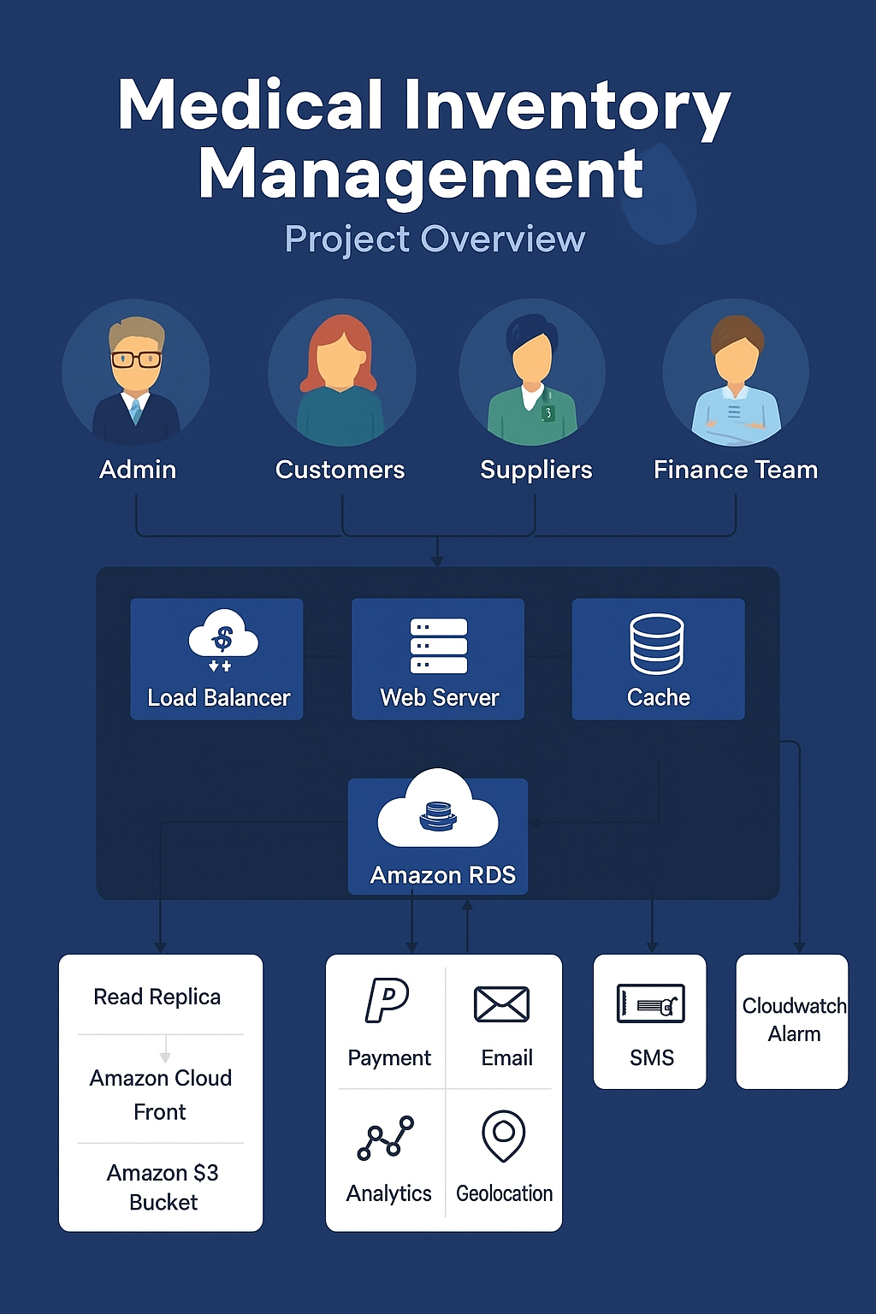

## 

## 1.2 Purpose

# The purpose of medical inventory management is to efficiently track, organize, and control medical supplies and equipment. It ensures smooth hospital operations, prevents stockout or wastage, supports timely patient care, and improves overall efficiency and cost-effectiveness.

# DEVELOPMENT PHASE

**Creating Developer Account:**

By using this URL[**-https://www.salesforce.com/form/developer-signup/?d=pb**](https://www.salesforce.com/form/developer-signup/?d=pb)

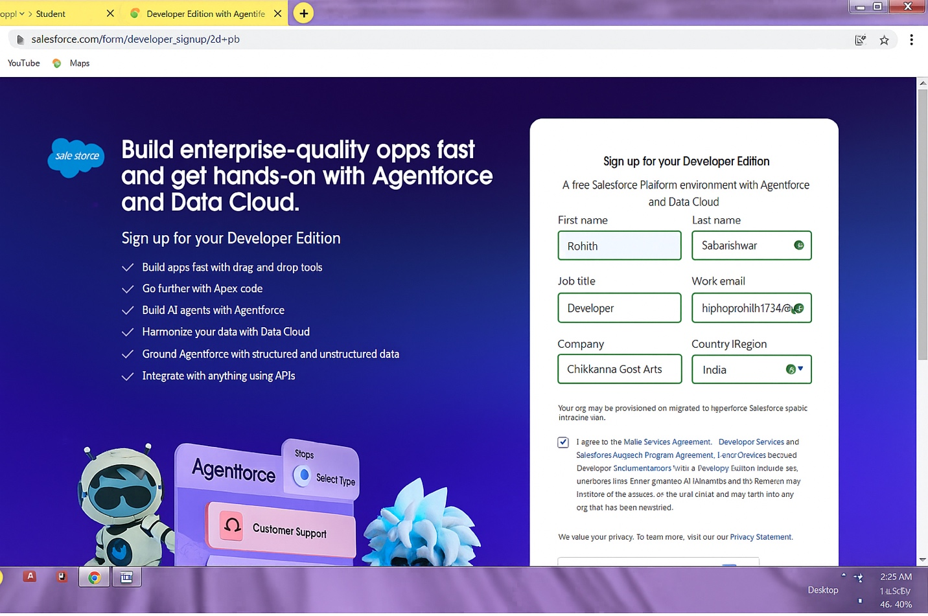

### Create a custom object as Product :

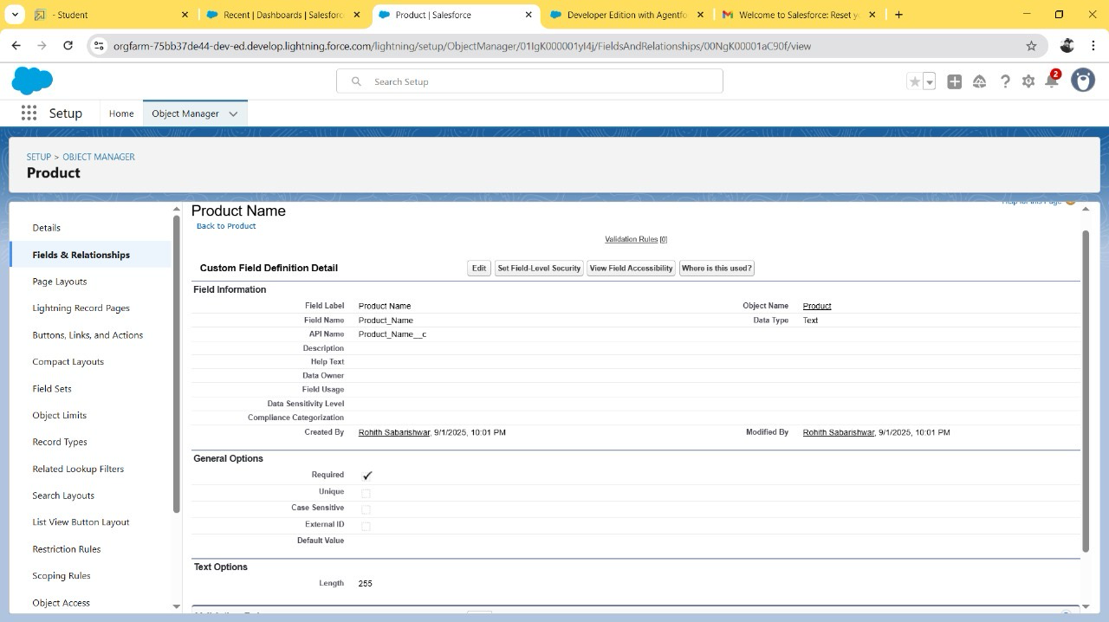

* Create a Tab for product object :

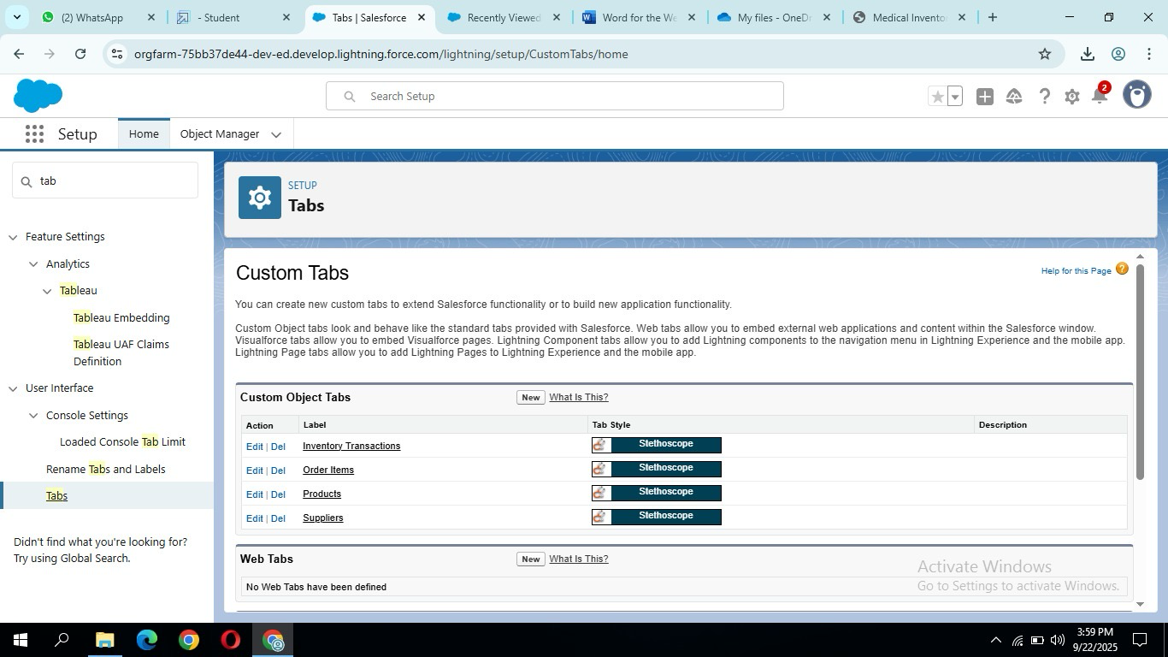

* Create a Lightning app Medical Inventory Management :

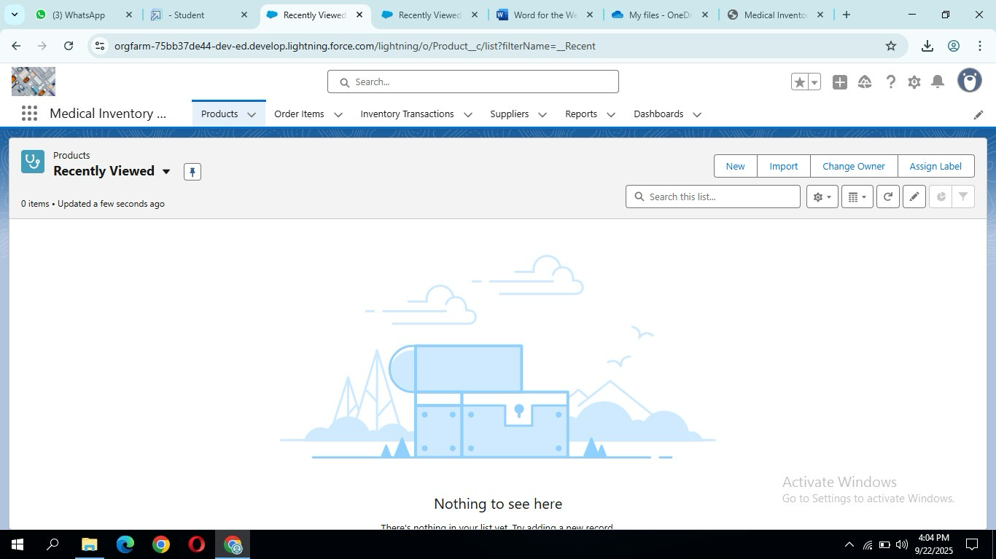

* Create given fields in Respective Object :

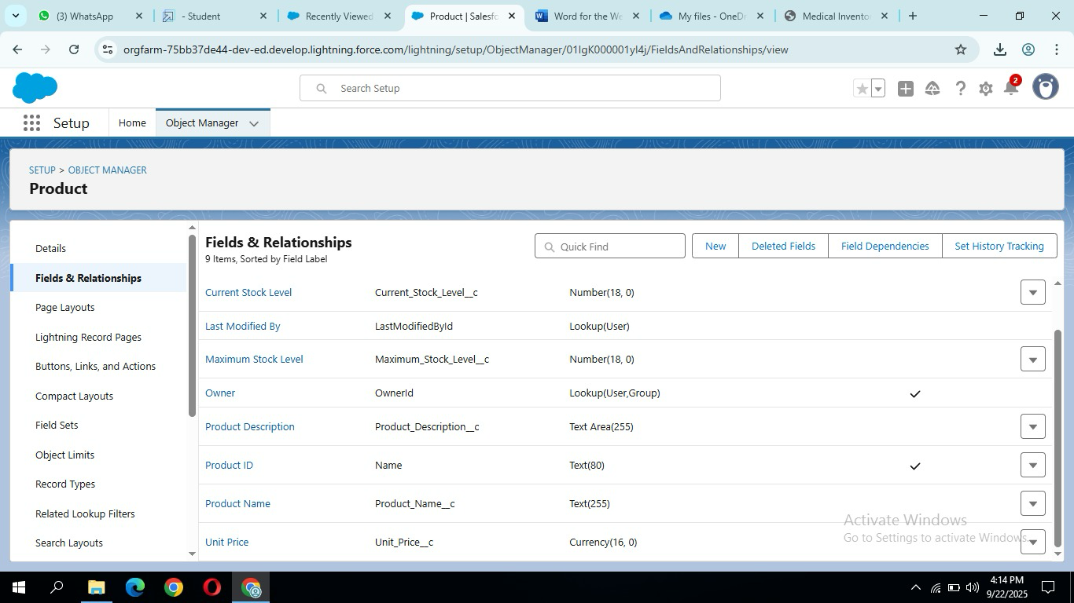

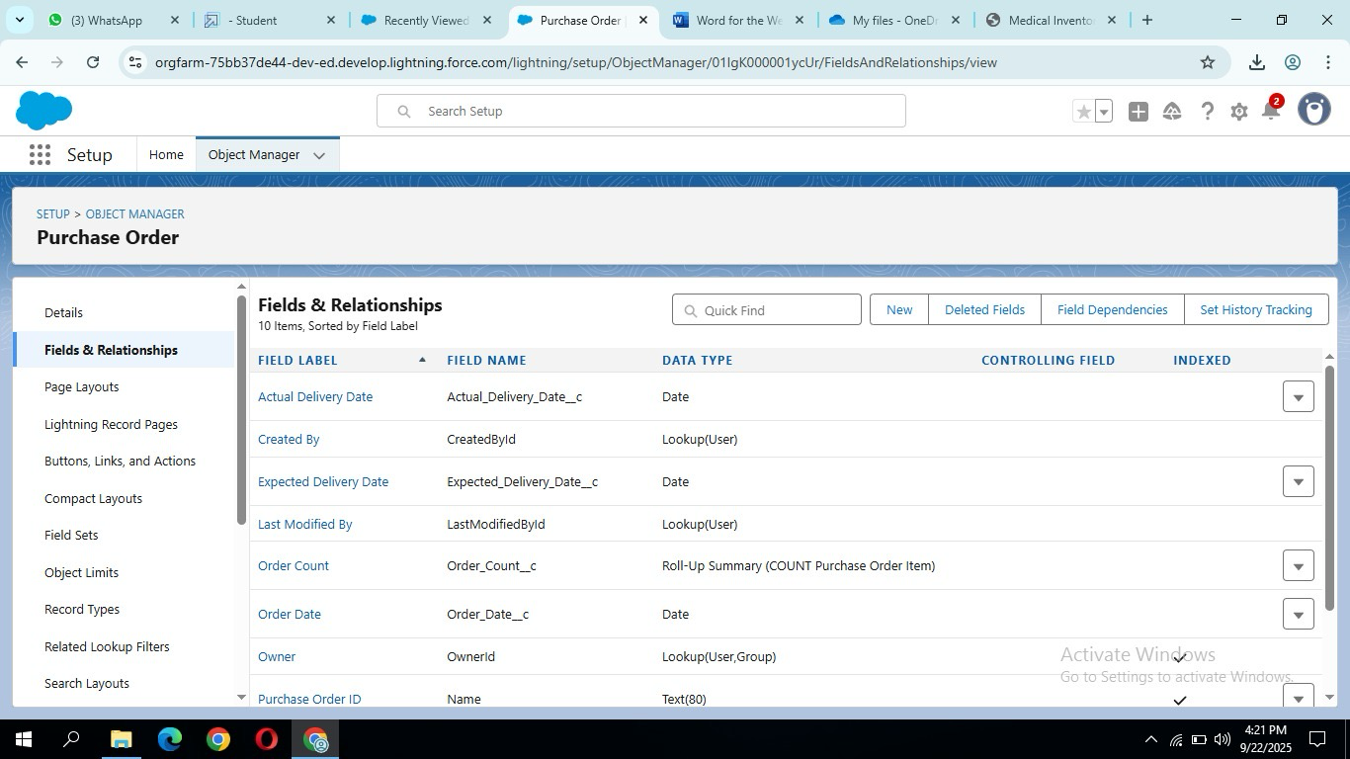

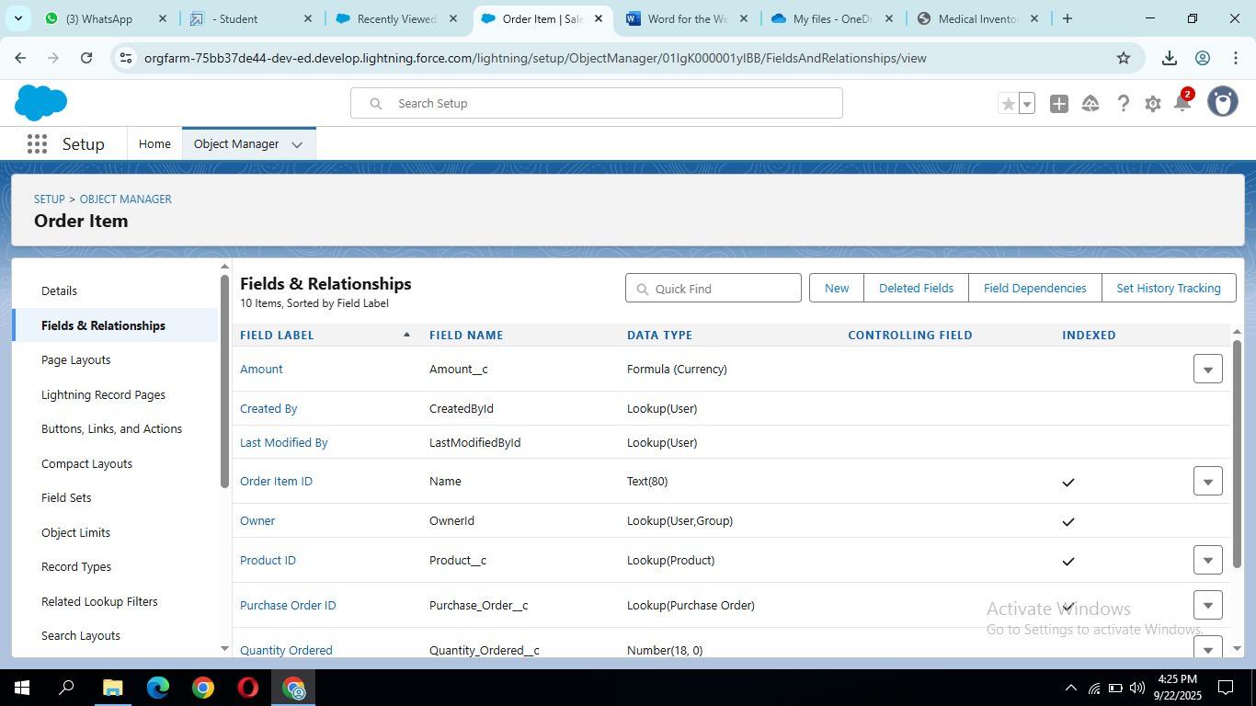

* Create page layout in respective layout :

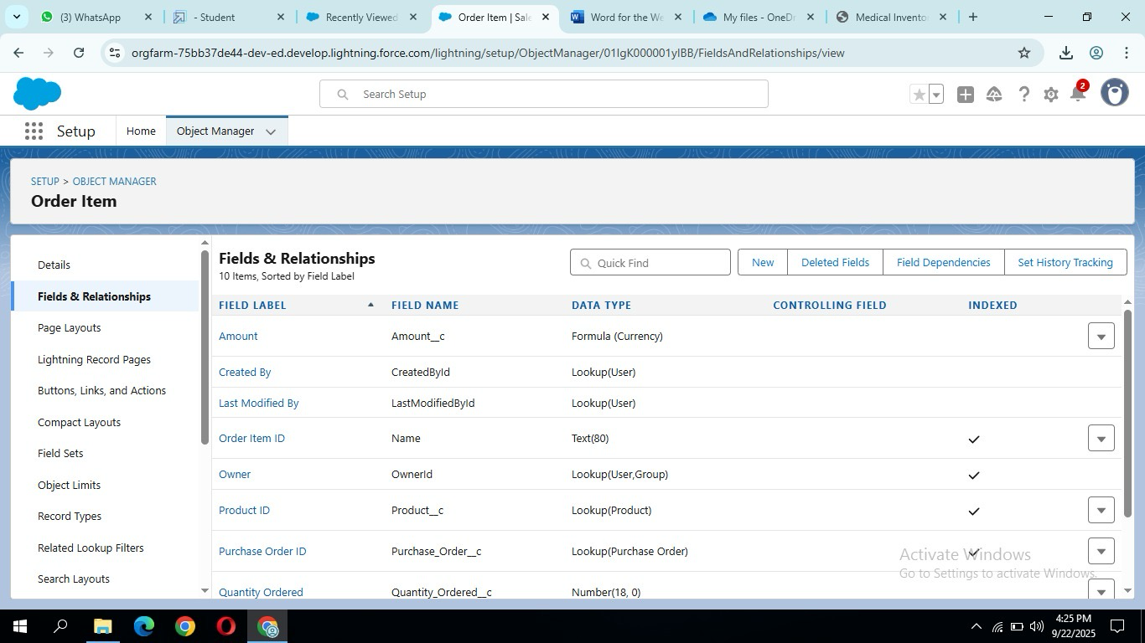

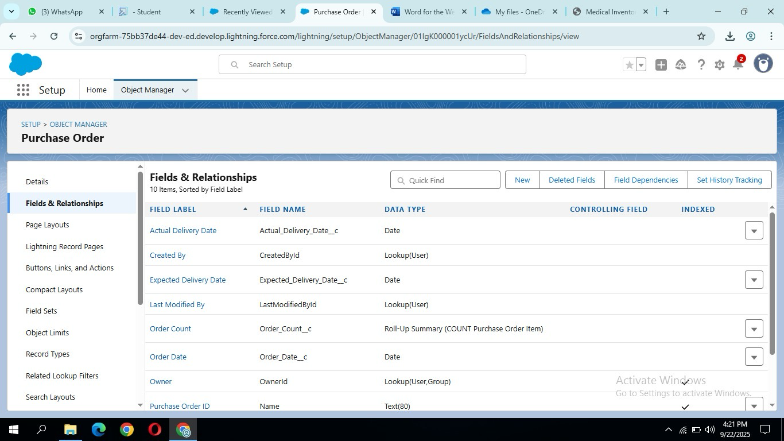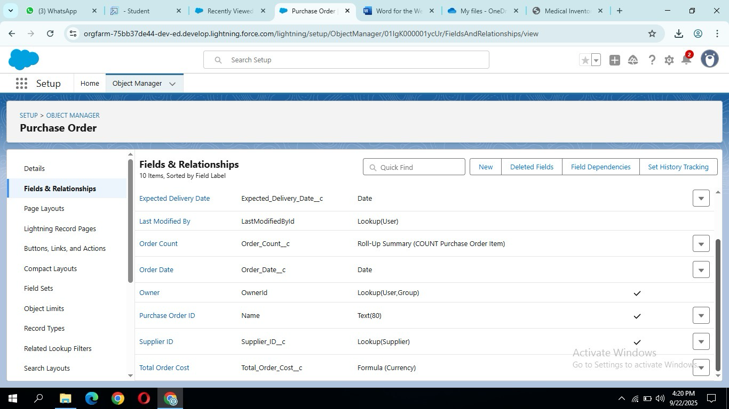

* Create compact layout to respective objectiva :

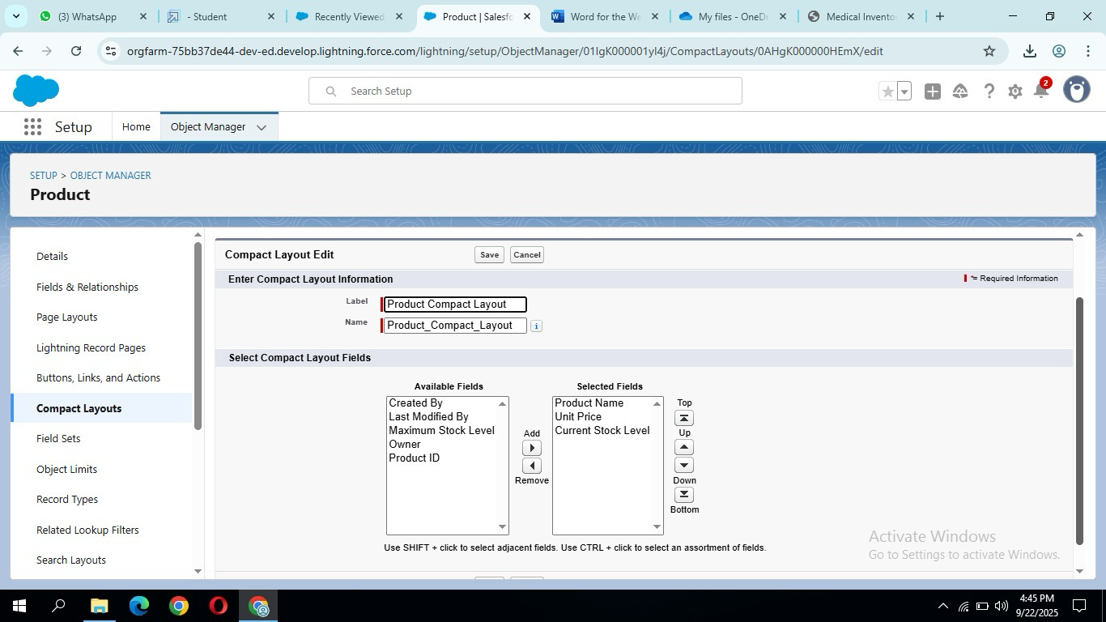

* Then do every steps by using the porjects guide :

